Software Requirements Specification

for

PA Historical Landmarks SaaS

Version 1.0 approved

Prepared by Insigma Studio

CISC 397 Course

February 3, 2018

Table of Contents

Preface 3

Introduction 3

Glossary 3

User Requirements 3

System Architecture 3

System Requirements 3

System Modeling 3

# Preface

This document serves to provide clarification of requirements for the intended system being built. Readers are expected to normally read the latter by following a user requirement and viewing related subsequent system requirements definitions. A versioning history of this document provides a summary of the changes made to requirements.

# Introduction

Many persons with a historical interest of PA needs a central hub to gather desired information. This system proposed aims to satisfy this need by providing a software-as-a-service (SaaS). Further requirements will be defined in appropriate sections below. Overall, the main goal is to provide a system that allows one to explore PA’s history for purposes like, but not limited to, educating others, self-interest, academic research, and touring.

# Glossary

* SaaS: Software as a Service

# User Requirements

## Use Cases

*Update as a user story is implemented in sprint.*

# System Architecture

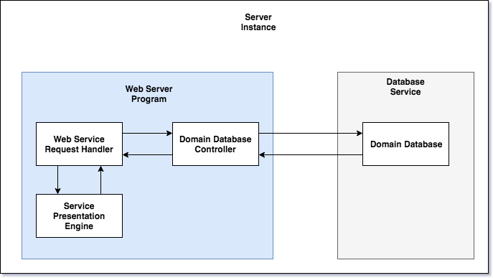

Fig. A1

# System Requirements

# System Modeling

# System Evolution

# Appendices

# Index

# 